**ERROR Screen shots**

1. The Below Error is coming from browsers(Firefox, Chrome, IE)

First drag mouse up to departure time 9:00 and do not leave here..

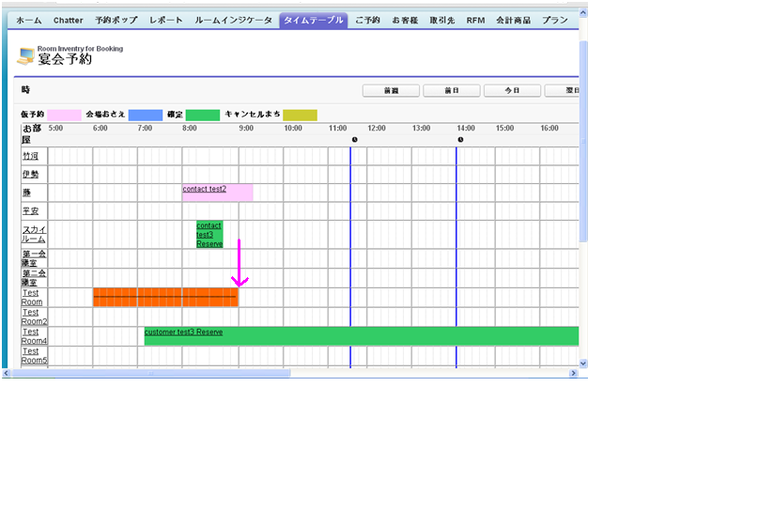

Now come back to 8:00 and leave the mouse. Now the Room details popup will appear. Observe in the popup departure time, its shows 9:00 only. But the red color drag is showing up to 8:00 only. Then enter all the details in popup and save the record.

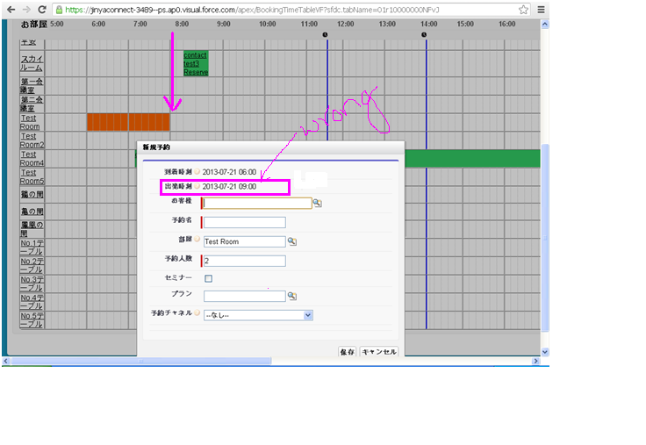

See in below image, the record is saved up to 9:00 only not to 8:00.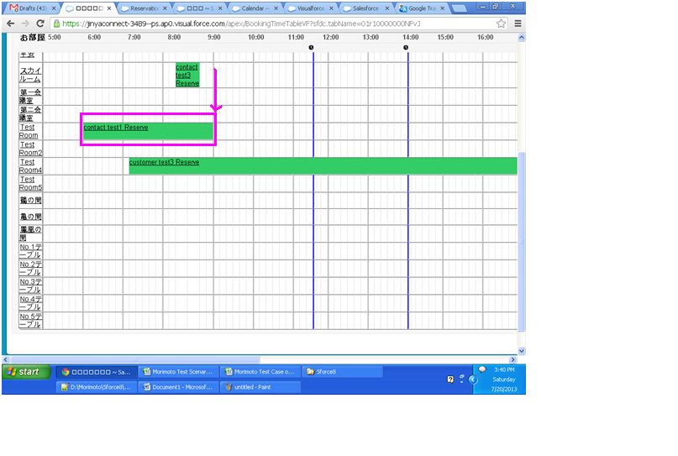

1. Dragged Line Error on page in browsers (Firefox & IE )

First drag up to some time and leave the mouse

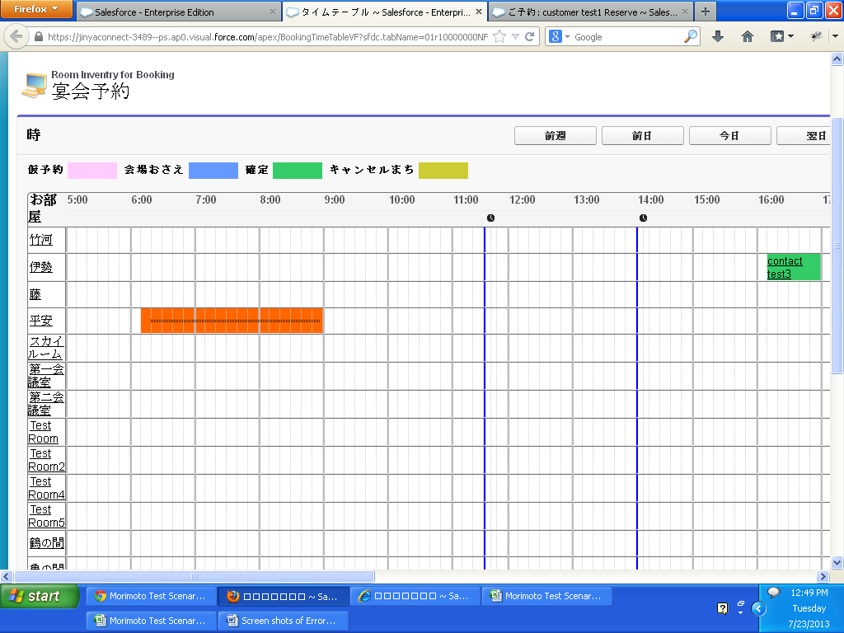

The Popup will shown up, observe the line which is dragged is also overriding on the popup.

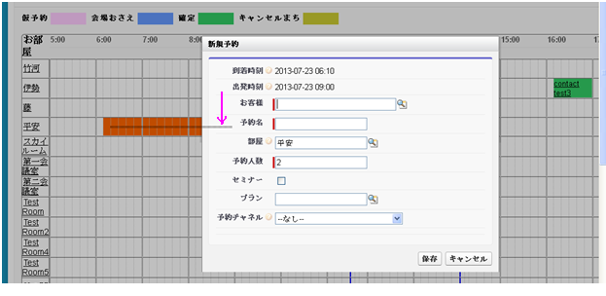

After entering the data in popup and save it. After record has been saved also, the dragged line is still appearing on the page.

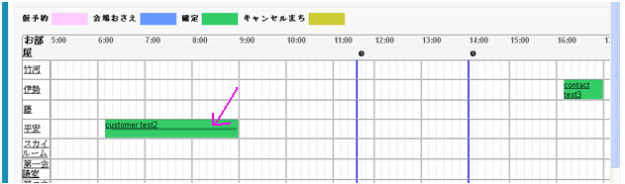

Even the popup is cancelled also, the dragged line will appear on the page.

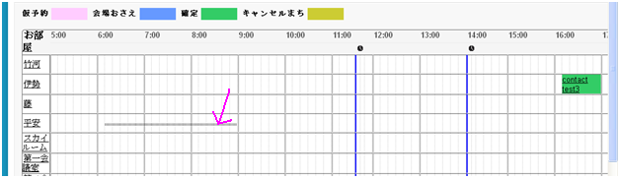

1. In IE 8 when dragged and popup is showing like below with not perfect design, and also Arrival time and departure time is showing wrong.

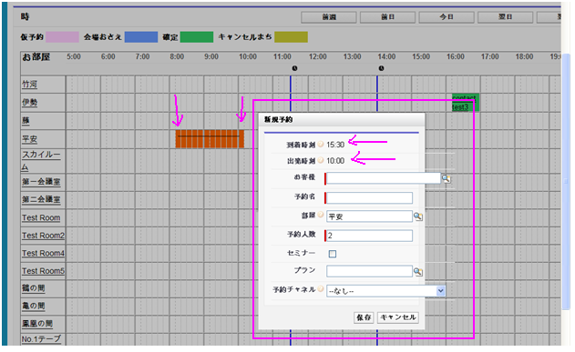

1. In IE 8, after data entered in popup and click on save button, while processing also the popup is not in blur state.

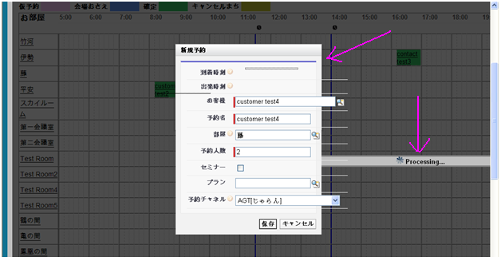

1. In IE 8, In Time Table page after dragged from Arrival time to Departure time, In popup the timings are not showing for some times.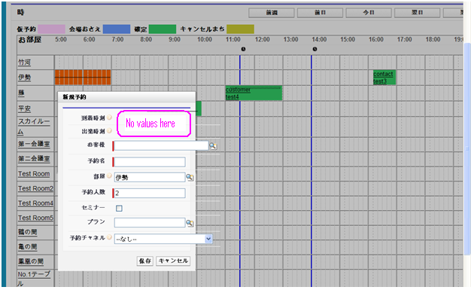
2. In Chrome and Firefox the Timing header is fixed at top of browser while scrolling.

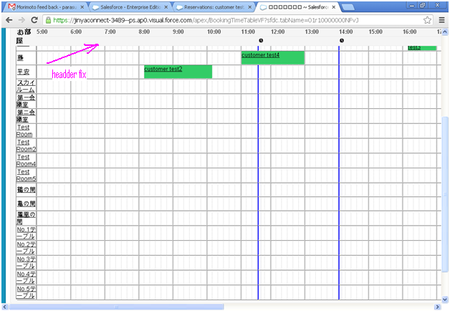

But whereas in IE 8, the header is not fixed at top of browser while scrolling